**AS24DXB002 LAB 3**

# Identify Entities

Based on the business rules, the key entities are:

1. **Employee**
2. **Department**
3. **Division**
4. **Project**

# Mention Attributes and Identify Keys

**1. Employee**

* Attributes: EmpID (PK), EmpName, Position, Salary, DeptID (FK, nullable for rovers)

**2. Department**

* Attributes: DeptID (PK), DeptName, DivisionID (FK), ManagerID (FK from Employee)

**3. Division**

* Attributes: DivisionID (PK), DivisionName, HeadID (FK from Employee)

**4. Project**

* Attributes: ProjectID (PK), ProjectName, StartDate, EndDate

**5. Employee_Project** (Associative Entity for many-to-many between Employee and Project)

* Attributes: EmpID (FK), ProjectID (FK)
* Primary Key: Composite (EmpID, ProjectID)

# ERD Diagram Code

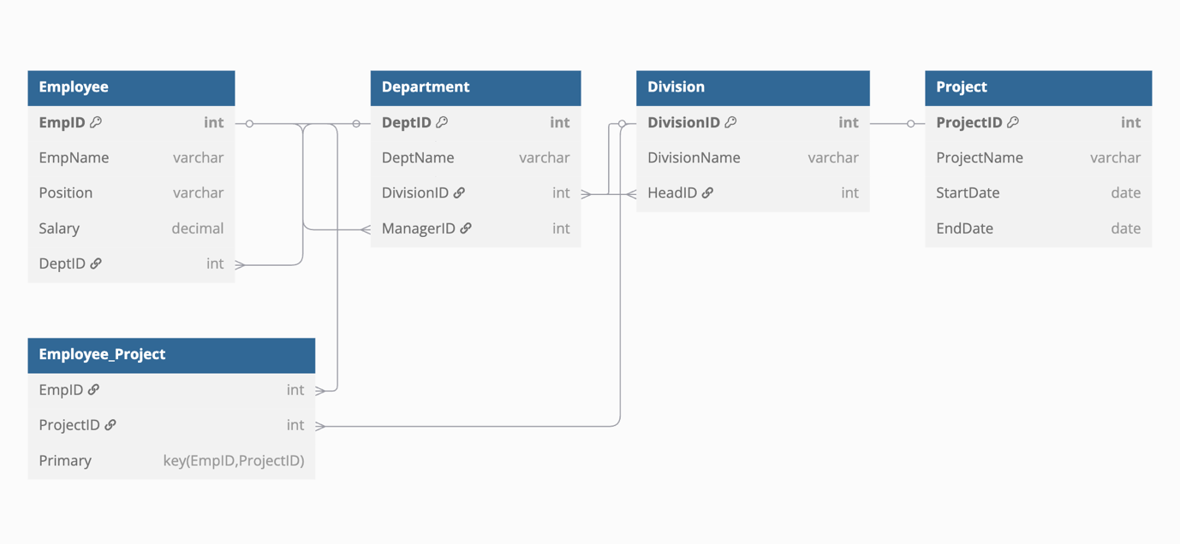

# CREATE TABLE Script

-- Insert Division first (no dependencies)

INSERT INTO Division (DivisionID, DivisionName, HeadID) VALUES

(1, 'Research & Development', 101),

(2, 'Human Resources', 102);

-- Insert Department next (now that Division exists, and ManagerID is temporarily NULL)

INSERT INTO Department (DeptID, DeptName, DivisionID, ManagerID) VALUES

(1, 'Engineering', 1, NULL),

(2, 'Recruitment', 2, NULL);

-- Insert Employees (DeptID now valid)

INSERT INTO Employee (EmpID, EmpName, Position, Salary, DeptID) VALUES

(101, 'Alice Johnson', 'Manager', 80000.00, 1),

(102, 'Bob Smith', 'Head', 85000.00, 2),

(103, 'Carol White', 'Engineer', 70000.00, 1),

(104, 'David Brown', 'Analyst', 65000.00, 1),

(105, 'Eva Green', 'Recruiter', 60000.00, 2);

-- Update Department now that ManagerID references existing employees

UPDATE Department SET ManagerID = 101 WHERE DeptID = 1;

UPDATE Department SET ManagerID = 102 WHERE DeptID = 2;

-- Now insert Projects

INSERT INTO Project (ProjectID, ProjectName, StartDate, EndDate) VALUES

(1, 'AI Optimization', '2024-01-01', '2024-06-30'),

(2, 'Talent Acquisition', '2024-02-15', '2024-08-15');

-- Insert into Employee_Project (join table)

INSERT INTO Employee_Project (EmpID, ProjectID) VALUES

(103, 1),

(104, 1),

(105, 2);

# INSERT INTO Script

INSERT INTO Division (DivisionID, DivisionName, HeadID) VALUES

(1, 'Research & Development', 101),

(2, 'Human Resources', 102);

INSERT INTO Employee (EmpID, EmpName, Position, Salary, DeptID) VALUES

(101, 'Alice Johnson', 'Manager', 80000.00, NULL),

(102, 'Bob Smith', 'Head', 85000.00, NULL),

(103, 'Carol White', 'Engineer', 70000.00, 1),

(104, 'David Brown', 'Analyst', 65000.00, 1),

(105, 'Eva Green', 'Recruiter', 60000.00, 2);

INSERT INTO Department (DeptID, DeptName, DivisionID, ManagerID) VALUES

(1, 'Engineering', 1, 101),

(2, 'Recruitment', 2, 102);

INSERT INTO Project (ProjectID, ProjectName, StartDate, EndDate) VALUES

(1, 'AI Optimization', '2024-01-01', '2024-06-30'),

(2, 'Talent Acquisition', '2024-02-15', '2024-08-15');

INSERT INTO Employee_Project (EmpID, ProjectID) VALUES

(103, 1),

(104, 1),

(105, 2);

# TABLES with Dummy Data

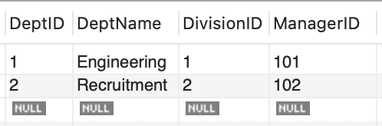

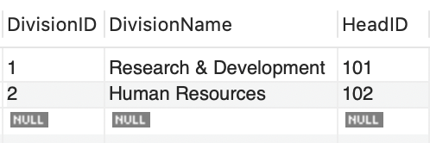

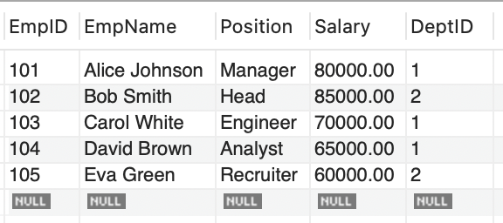

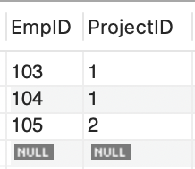

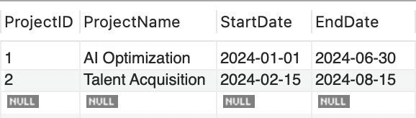

# Primary key – Foreign Key

|  |  |  |
| --- | --- | --- |
| **Table Name** | **Primary Key(s)** | **Foreign Key(s)** |
| **Division** | DivisionID | HeadID → Employee.EmpID (optional, logical FK if modeled strictly) |
| **Department** | DeptID | DivisionID → Division.DivisionIDManagerID → Employee.EmpID |
| **Employee** | EmpID | DeptID → Department.DeptID (nullable for rovers) |
| **Project** | ProjectID | — |
| **Employee_Project** | Composite: EmpID, ProjectID | EmpID → Employee.EmpIDProjectID → Project.ProjectID |